

CSE470: Software Engineering  
Section: 5  
Group: 3  
**SPRINT 4**

|  |  |
| --- | --- |
| Sadat Mahmud | 22301301 |
| Rana Mustafa | 21101060 |
| Atoshi Samadder | 21301706 |
| Nabil Nashit | 21201060 *(Scrum Master)* |

**Software: VisiNexus –** Connecting insights through vision

**Requirements**

1. Real-time demos for computer vision applications such as object detection, emotion recognition, etc.
2. Interactive tools for learning and understanding computer vision applications
3. Documentation and tutorials
4. API access and integration guide
5. User Management
6. Virtual coins for purchasing accessibility

**Framework Setup**

|  |  |
| --- | --- |
| Frontend | React.js |
| Backend | Express.js |
| Computer Vision Models | OpenCV and TensorFlow |
| Database | MongoDB |
| Hosting | GoDaddy |

**Workload Distribution**

|  |  |
| --- | --- |
| Sadat Mahmud | Project Manager: Oversee environmental setup, and proper deployment |
| Rana Mustafa | Computer Vision Specialist: Optimize Computer Vision Models |
| Atoshi Samadder | Frontend Developer: Develop the user interface |
| Nabil Nashit | Backend Developer: Build the server-side logic and API endpoints |

Landing Page:

Signup Page:

Login Page:

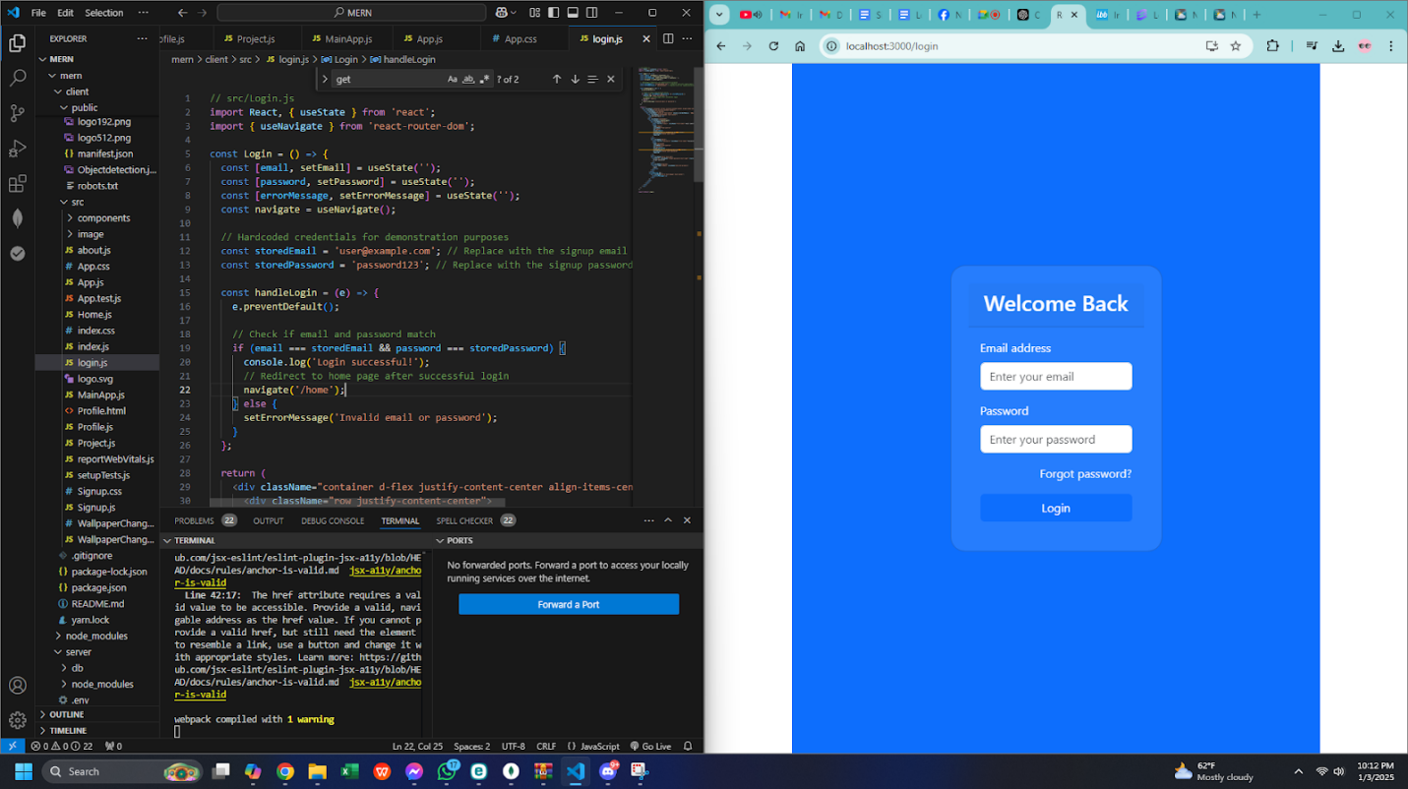

Home Page:

Project Page:

About Us Page:

